- For positive and Negative (only):
siebert/sentiment-roberta-large-english

- distilbert/distilbert-base-uncased-finetuned-sst-2-english
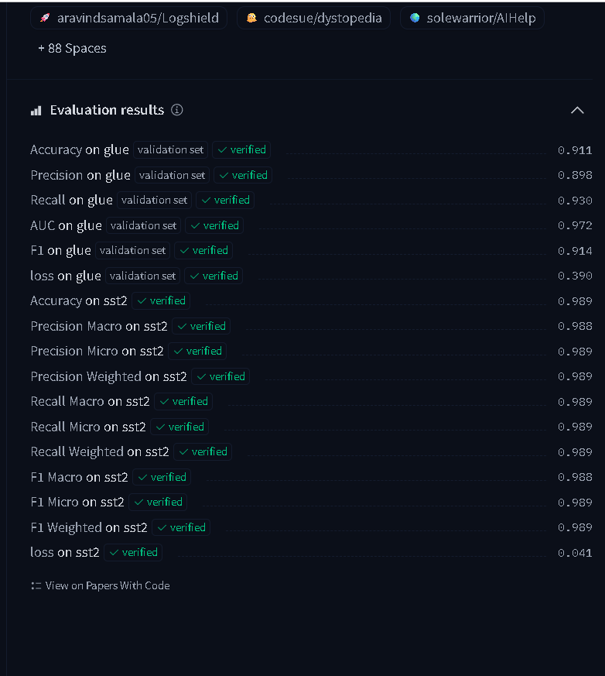

- For Fine-Grained Emotion Analysis: bhadresh-savani/distilbert-base-uncased-emotion.

- For positive negative and neutral:

cardiffnlp/twitter-roberta-base-sentiment-latest.

